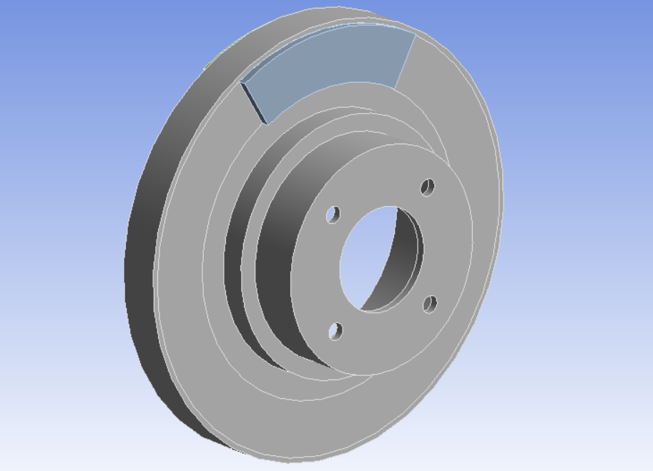

Project 2: Optimization of a Disc Brake System

MAE598

David Wittman

## Model Analysis

The main model of the system consists of a rotor that is spinning at high speeds. This is the most common method (besides drum brakes) for stopping moving vehicles. Both sides of the disk are a smooth surface that interface with arc shaped pads that use friction to stop the spinning wheels of the moving vehicle. With friction comes both heat and a potential for a mixture of both dynamic and static, causing potential for failure due to resonance. The scope of this model covers only the transient thermal, modal, and structural analyses within FEA software.

In this scope, we are limited to ANSYS and the power provided by the somewhat limited toolset. Throughout will be outlined how the rotor will be optimized to reduce overall volume using common optimization techniques.

## 1.1 Structural Analysis

The structural system consists, as outlined above, a total of three components. The rotor is assumed as structural steel, while the brake pads are assumed as cast iron. When braking, the pads squeeze the rotor. This force has been estimated as a $1.0495 {10}^{7}Pa$ of both brake pad on each side of the rotor. In addition, it is assumed that the rotor is rotating at $250\frac{rad}{sec}$ which is around $2400 RPM$. From this, if we consider the most common tire diameter (17 in), we can see that the speed is around $60 mph$, another common speed on highways/state routes. From that simple calculation it is confirmed that this model may be representative of real-life conditions, still within the project scope. The initial diameter of the rotor is 250mm in diameter, initial thickness of $25mm$, and total rotor diameter of $9.967 {10}^{5} {mm}^{2}$.

Using Von-Mises criteria, it is found that the maximum stress is $1.4299 {10}^{7}Pa$. This is one of three parameters that will be used in the Design of Experiments.

## 1.2 Modal Analysis

Modal Analysis is often overlooked by those unfamiliar with vibration and resonance. Resonance is the passive vibrational frequency of an object. When fastening components that carry vibrational modes, it can be very common for failure to occur with little to no evidence as to the failure mode. For the minor deformations created by these vibrations shown below:

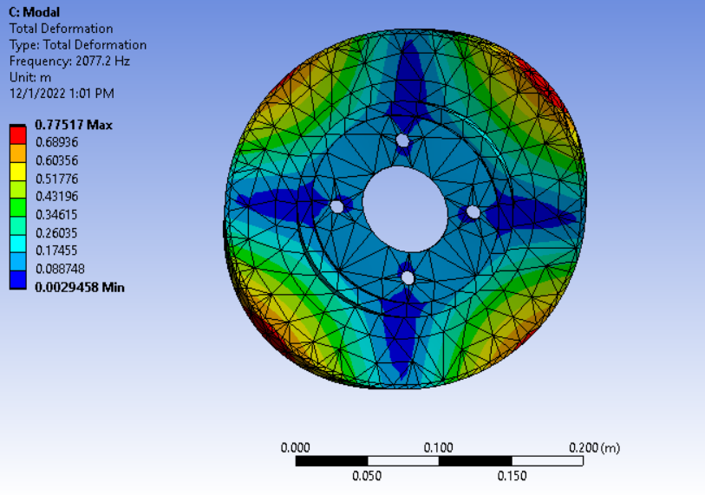

From above, the maximum deformation is shown as $7.78 {10}^{-1}m$ which is significant when rotating at 2400 RPM.

## 1.3 Thermal Analysis

## Optimization

Post-initialization of all applicable models, the parameters pulled from past analyses will be acting as design variables in the design of experiments section of analysis. The design of optimization will be fed into ANSYS optimization methods

## 2.1 Design of Experiments

## 2.2 Response Surface

## 2.3 Troubleshooting multiple DoE Types

## Conclusion